**PARKING COST CALCULATOR –** <http://www.shino.de/parkcalc/>

**Brief Description**

This is basically a user interface to calculate, according to a defined set of fields, the amount a user has to pay under the concept of parking.

The fields that need to be populated are: type of parking lot, entry date and time, and leaving date and time.

The costs have been set per type of parking lot and the charges range from values per fraction of an hour, hourly, daily, weekly, among others.

Once the fields have been completed, the button “Calculate” needs to be clicked and the estimated parking cost will be shown.

**Identified Bugs**

1. **Parking Lot field**:
   1. **Once the “Calculate” button has been clicked, it always returns to “Valet Parking” even if another option was selected before the calculation.**

For example: Economy parking selected and returns to Valet Parking after calculation.

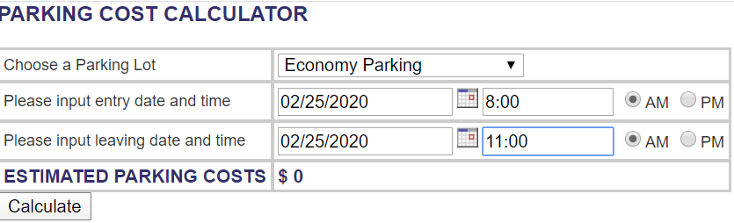

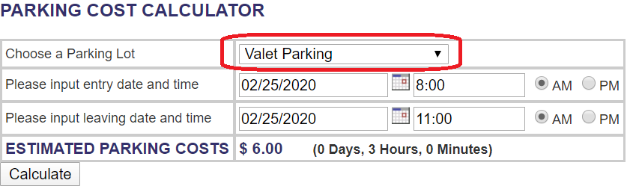

* *How it should work*: The parking lot field should maintain the initial selected option for which the calculation was made.

1. **Entry Date and Leaving Date fields:**
2. **The field allows to enter the date in the DD/MM/YYYY format as well as MM/DD/YYYY (which is the format requested).**

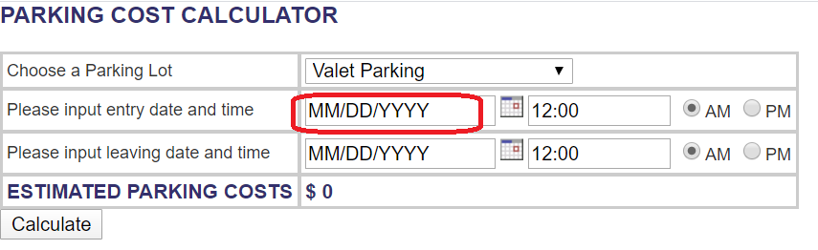

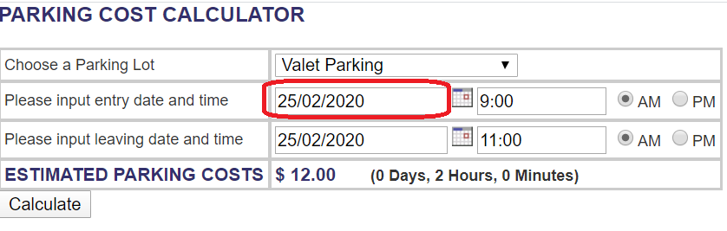

* *How it should work*: It should only accept MM/DD/YYYY format even when the date is typed and not chosen from the calendar.

1. **In the value for DD (Day), when using the format MM/DD/YYYY, you can enter any**

**number from 1 to 6543 (depending of the month typed) without receiving any error.**

For example: In the case of choosing Month 1:

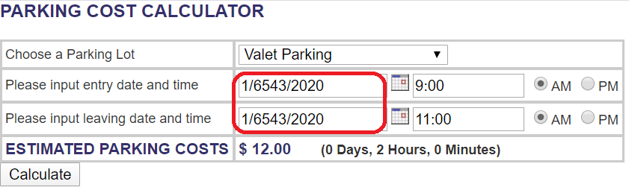

After the maximum day (DD) possible, you receive the following code error:

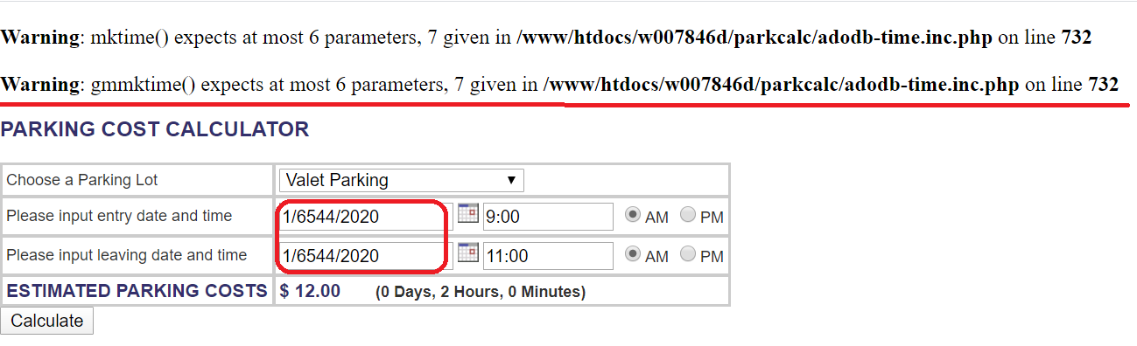

* *How it should work*: It should not accept Day field (DD) input of more than 2 digits and it should be according to the month (MM) typed. For example, month 01 the maximum possible day should be 31, but for month 02, the maximum possible day should be 29 (in case of leap year).

1. **In the value for MM (Month), when using the format MM/DD/YYYY, you can enter up to 3-digit numbers.**

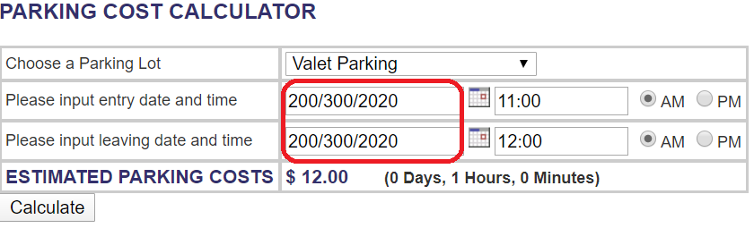

* *How it should work*: It should accept a maximum of 2 digits for the Month field (MM) and restrict them to 01 (Jan) to 12 (Dec).

1. **If you input only 2 digits, instead of 4, for the YYYY, you should receive an error message explaining you should correct the date**; however, you see the following:

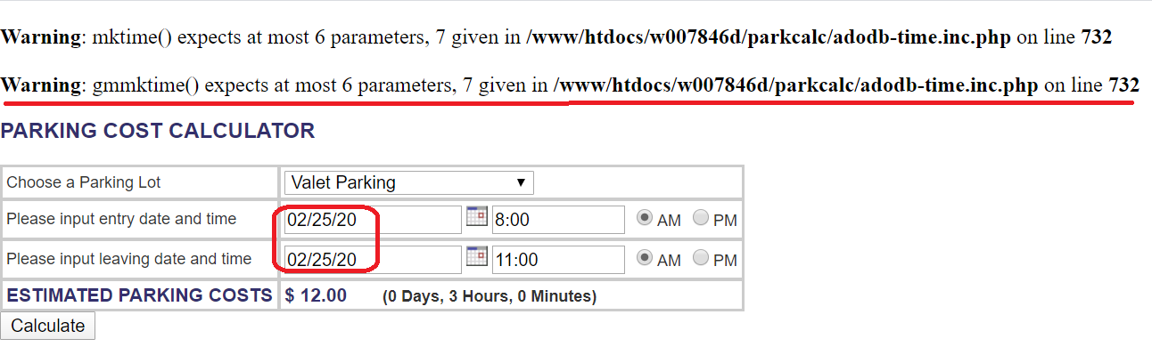

* *How it should work*: It should not accept YYYY input of less than 4 digits when typed and should display an error message it happens. (In addition, depending on the requirement, the date field should be limited to the current year +/- 2 years)

1. **Entry Time and Leaving Time fields:**
   1. **If the hour is typed using the 24-hour clock format and choose PM, the program adds 12 hours to the original time entered when clicking “Calculate” and the selection changes to “AM”.**

**This affects the calculation of parking costs in cases were the entry time is AM and the leaving time is PM because it includes in the cost 12 additional hours. (See** **example 1****).**

**In the case where both, entry and leaving times, are PM, although the parking cost is not affected because the difference remains the same, it shows a change in the original hours and shows as AM. (See** **example 2****)**

Example 1:

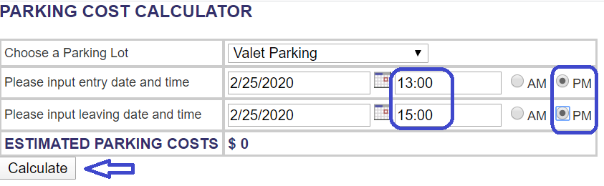

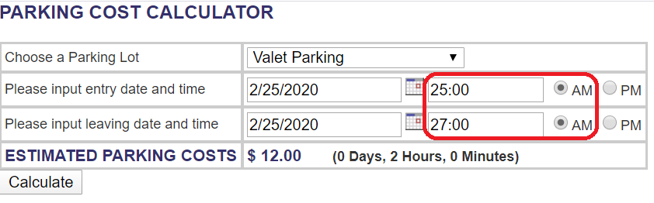

Example 2: Instead of charging for 4 hours, the calculation is based on 16 hours.

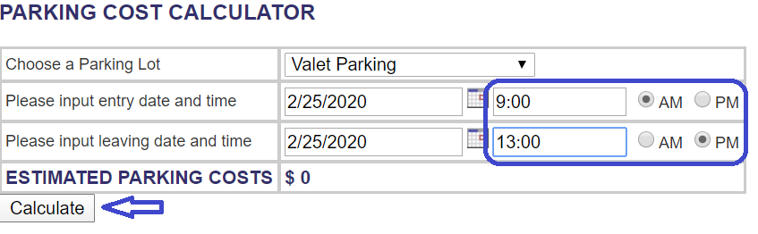

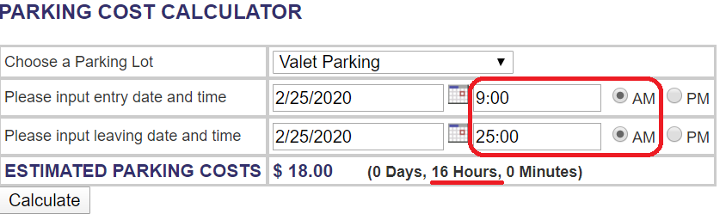

* *How it should work*: The time field should work based on the 12-hour clock format (1-12 numbers only) and select the corresponding AM or PM option. While performing the calculation and showing the estimated parking costs, the values originally entered must be shown.